These instructions are a guide for the format and style for manuscripts submitted to The Compass. Additional questions regarding manuscripts can be directed to the editor at editor@sgeearth.org. Please try to use the styles as defined in the document. Please put the primary author name in the footer (where it says “Author et al.”).
Author note: Please delete all explanatory text (Style: SGE Explanatory Text) when submitting!
SGE Compass manuscript template: Capitalize only proper nouns and avoid using all caps (Style: SGE Title)
James Hutton^{1*}, Alfred L. Wegener², Charles Lyell³, and John W. Powell² (Style SGE Authors)
Note: Please add subscript numbers for different affiliations. Please add a superscript star (*) for the corresponding author email.
¹ Affiliation 1, Department, Institution, Full Mailing Address, USA (Style SGE Affiliation)
² Affiliation 2, Department, Institution, Full Mailing Address, USA (Style SGE Affiliation)
³ Affiliation 3, Department, Institution, Full Mailing Address, USA (Style SGE Affiliation)
* Corresponding Author Email: editor@sgeearth.org (Style SGE Affiliation)
ABSTRACT
Abstracts should not exceed 250 words.
(Style: SGE Normal) Lorem ipsum dolor sit amet, consectetur adipiscing elit, sed do eiusmod tempor incididunt ut labore et dolore magna aliqua. Vel eros donec ac odio tempor orci dapibus ultrices in. Scelerisque eleifend donec pretium vulputate sapien nec sagittis aliquam. Tellus orci ac auctor augue mauris augue neque gravida in. Nec ultrices dui sapien eget mi proin. Tristique senectus et netus et malesuada fames. At volutpat diam ut venenatis. Quis lectus nulla at volutpat diam ut venenatis tellus.
KEYWORDS
Please enter four to eight keywords that are relevant to your research, separated by commas.
(Style: SGE Normal) Keyword 1, Keyword 2, Keyword 3, Keyword 4, Keyword 5
INTRODUCTION (Style: SGE Heading 1)
Text for the article goes here. Please include relevant sections such as Introduction, Study Area, Methods, Results, Discussion, Conclusion, and any other necessary sections. Minor headings (First level through 5th level headings, Style SGE Heading 2 - 5) could include Purpose, Geologic Setting, Previous Investigations, and Field Evidence, or appropriate minor headings.
Equations can be entered by the equation tool (Insert > Equation). Please reference the equations in order of appearance and fully explain all variables. You can also make the editor extremely happy by including the LaTeX version of the equation, which is what will need to be done in the final versions of the paper. You can use style SGE Equation LaTeX for it include that below the Microsoft Word Equation. You can find a good Equation Editor here: https://editor.codecogs.com/.
For example… Equation 1 provides solutions to the quadratic equation, as:
$$x=\frac{-b±\sqrt{b^{2}-4ac}}{2a}$$
x = \frac{-b \pm \sqrt{b^2 - 4ac})}{2a}
Where a, b, and c are … and x is ….
Lorem ipsum dolor sit amet, consectetur adipiscing elit, sed do eiusmod tempor incididunt ut labore et dolore magna aliqua. In mollis nunc sed id semper risus in. Sagittis aliquam malesuada bibendum arcu vitae. Sit amet mauris commodo quis. Porta non pulvinar neque laoreet suspendisse interdum. Dictum sit amet justo donec enim diam vulputate ut pharetra. Semper eget duis at tellus at urna condimentum. Dui ut ornare lectus sit amet. Lectus vestibulum mattis ullamcorper velit sed. Sed ullamcorper morbi tincidunt ornare massa eget.
First Level Heading (Style: SGE Heading 1)
Lorem ipsum dolor sit amet, consectetur adipiscing elit, sed do eiusmod tempor incididunt ut labore et dolore magna aliqua. Nisl purus in mollis nunc sed.
Sed tempus urna et pharetra pharetra massa massa ultricies mi. Donec pretium vulputate sapien nec sagittis aliquam malesuada.
Second Level Heading (Style: SGE Heading 2)
Use Style SGE Heading 2 for subdivisions within SGE Heading 1.
Lorem ipsum dolor sit amet, consectetur adipiscing elit, sed do eiusmod tempor incididunt ut labore et dolore magna aliqua. Nisl purus in mollis nunc sed.
Third Level Heading (Style: SGE Heading 3)
Use Style SGE Heading 3 for subdivisions within SGE Heading 2.
Sed tempus urna et pharetra pharetra massa massa ultricies mi. Donec pretium vulputate sapien nec sagittis aliquam malesuada. Lorem dolor sed viverra ipsum nunc aliquet bibendum enim facilisis.
Fourth Level Heading (Style: SGE Heading 4)
Use Style SGE Heading 4 for subdivisions within SGE Heading 3.
Sed tempus urna et pharetra pharetra massa massa ultricies mi. Donec pretium vulputate sapien nec sagittis aliquam malesuada. Lorem dolor sed viverra ipsum nunc aliquet bibendum enim facilisis.
Fifth Level Heading (Style: SGE Heading 5)
Use Style SGE Heading 5 for subdivisions within SGE Heading 4. If you need additional headings, please contact the editor.
Sed tempus urna et pharetra pharetra massa massa ultricies mi. Donec pretium vulputate sapien nec sagittis aliquam malesuada. Lorem dolor sed viverra ipsum nunc aliquet bibendum enim facilisis.
NOTE ABOUT CITATIONS
Citations should be fully referenced in the References Cited section. In-text citation should be written as follows: “…as Rodgers (1957) demonstrated…” or “…it is well documented (Dunbar and Rodgers, 1957; Tevesz et al., 1980)….” You may also use “and others” in lieu of “et al.” for in-text citations, e.g.: “… Tevesz and others (1980) stated ….”
NOTE ABOUT FIGURES AND TABLES
Reference each figure as they appear in the document as an inline citation like: “…Figure 1 clearly shows…” or “… the study area (Figure 1)….” The individual figures will be listed in the “Figures” section below.
Tables are referenced in a similar manner as figures but are included in the “Tables” section below.
ACKNOWLEDGEMENTS
Optional, but can include individuals who assisted in the study, reviewers, funding agencies, etc.
(Style: SGE Normal) Lorem ipsum dolor sit amet, consectetur adipiscing elit, sed do eiusmod tempor incididunt ut labore et dolore magna aliqua. In mollis nunc sed id semper risus in. Sagittis aliquam malesuada bibendum arcu vitae. Sagittis aliquam malesuada bibendum arcu vitae. Sagittis aliquam malesuada bibendum arcu vitae.
REFERENCES CITED
Citations are to appear in alphabetical order. Please refer to the GSA reference guidelines and examples at the following URL for formatting your references cited section: https://www.geosociety.org/documents/gsa/pubs/GSA_RefGuide_Examples.pdf
Landes, K.K., 1966. A scrutiny of the abstract, II. Bulletin of the American Association of Petroleum Geologists, v. 50(9), p. 1992.
Dunbar, C.O. and Rodgers, J., 1957. Principles of Stratigraphy, John Wiley & Co., New York.
Rodgers, J., 1959. The meaning of correlation. American Journal of Science, v. 257(10), p. 684-691.
Tevesz, M.J., Soster, F.M., and McCall, P.L., 1980. The effects of size- selective feeding by oligochaetes on the physical properties of river sediments. Journal of Sedimentary Petrology, v. 50(2), p. 561-568.
Figures
Figures should be high resolution (at least 300 dpi; 600 dpi preferred) and scaled to fit a maximum of 7.5 inches wide by about 7.5 inches tall (to allow room for a figure caption). Please do not wrap text around the image. We prefer vector-based images (svg, png, etc) versus raster image formats (jpg, gif, etc); raster image formats are okay as long as they have high-enough resolution. Maps should contain all necessary map elements (north arrow, scale bar, legend, reference to a larger geographic location [i.e., a map that shows a study area shows a larger area, like a state or country], etc.); consider having geographic coordinates on the collar of the image to help the reader orient to the location (see Figure 2 for example of this).
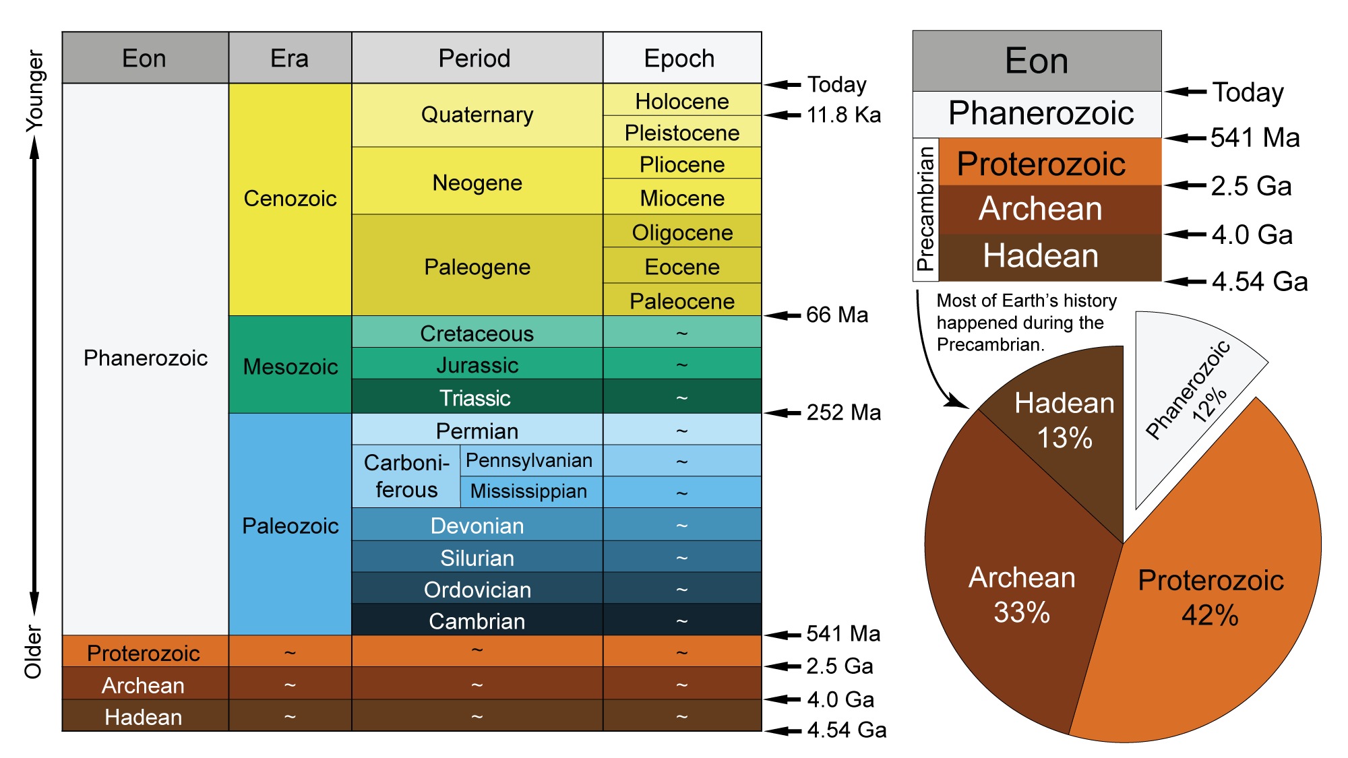
Figure 1: Figure Caption goes here.
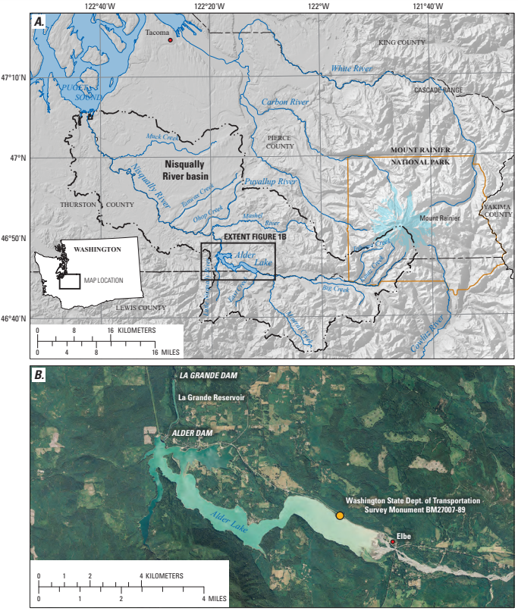
Figure 2: Example of a map element figure showing all necessary map elements, including geographic information in the collar. You may reference Figure 2A and Figure 2B both in the figure caption and text.
Tables
Tables may be included either in the text or as attached Microsoft Excel tables. If you choose to include the table here, please keep all borders and use the necessary styles (SGE Table Header, SGE Table Cell). Tables that wrap over multiple pages will be dealt with prior to publication. Tables that may not be completely relevant to the section or paper can be included as an appendix (see instructions for that below). You may also include table comments (Style SGE Table Comment) that will appear below the table, with necessary reference notations as superscripts.
Table 1: Table caption goes here.
Header | Header | Header¹ | Header²
Data | Data | Data | Data
Data | Data | Data | Data
Data | Data | Data | Data
¹ Table comment 1 Goes here. In mollis nunc sed id semper risus in. Sagittis aliquam malesuada bibendum arcu vitae. Sagittis aliquam malesuada bibendum arcu vitae.
² Table comment 2
Table 2: Table caption goes here.
This is an example of a table that would be included externally (as a Microsoft Excel document). Please include the table caption but make a note in the document with the file name.
Table is included externally as “table2.xlsx”.
Appendices
Appendices should be referenced in order as they are mentioned in text, and only should be used if necessary. Text, figures, and tables all can be referenced in a similar manner as text, figures, and tables for the rest of the document. You may reference tables and figures in the appendices as “Appendix A-1”, etc.
suggested peer reviewers
In this section, please list the name and contact information for a couple of potential peer reviewers. The editor may choose to use different peer reviewers.
Next Steps: The editor of The Compass will solicit each manuscript for peer review. Once comments are received from the peer reviewers, the editor will send comments back to the corresponding author for review, edit, and incorporation. It is understood that it is the author’s responsibility to revise the manuscript to acceptable standards. Submitted manuscripts that do not follow this step will be returned and risk nonpublication.
Questions and Answers: If you have any additional questions or style elements not mentioned in this document, please forward your questions/comments to the editor at editor@sgeearth.org.

